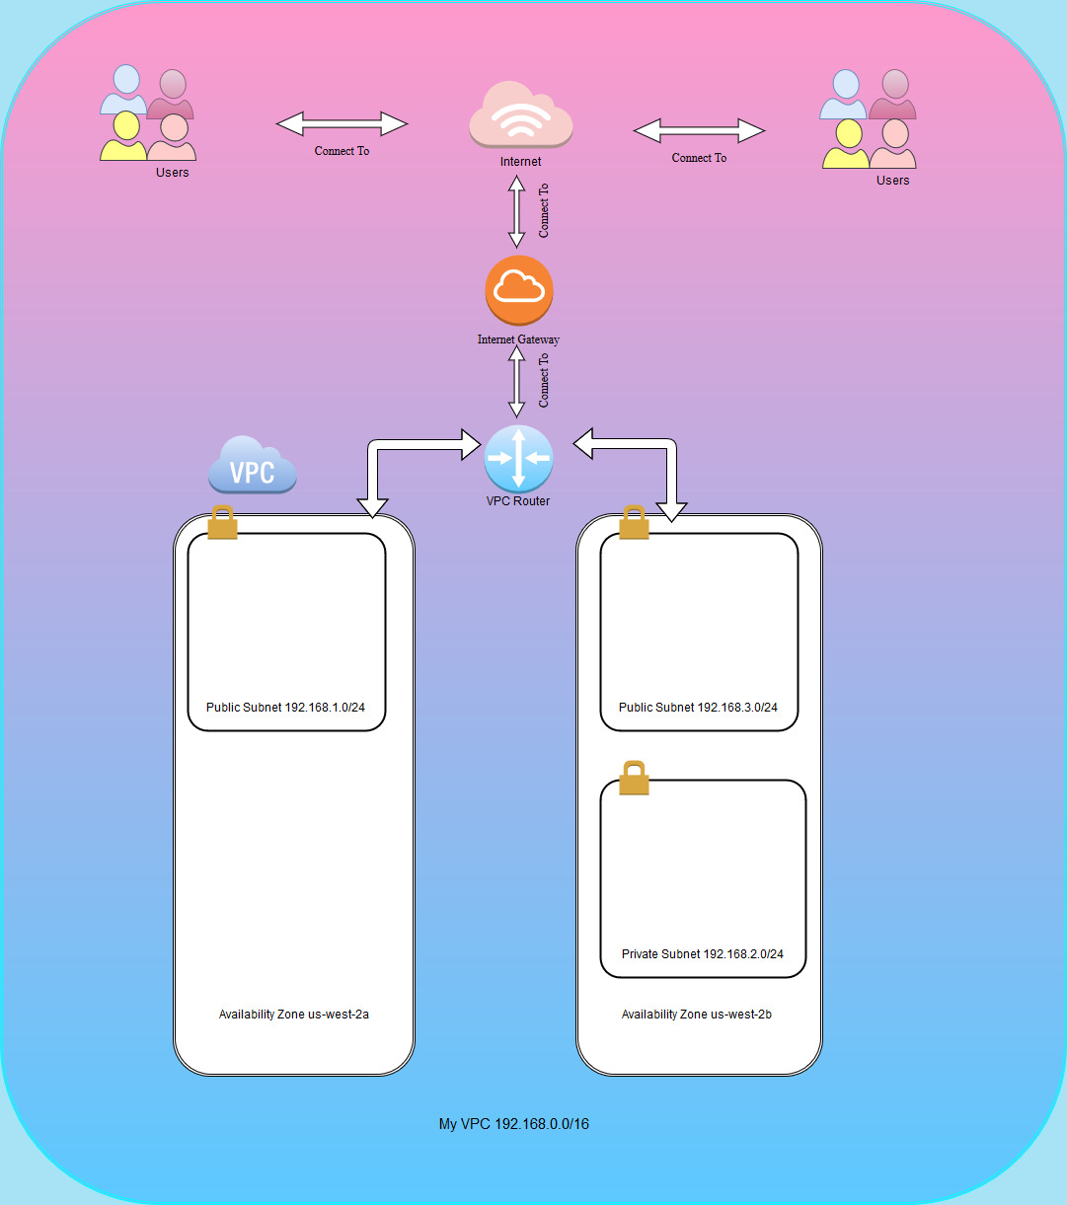

Cloud Assignment - AWS

Aws Virtual Private Cloud

Michaela Healy | Information Technology | Year 2

As part of this assignment I created a Virtual Network using Amazon AWS for a small company. I decided to make a /16 network for the company which caters for 64 thousand addresses.

# VPC – Virtual Private Cloud

Firstly, I created my VPC (Virtual Private Cloud) which allows me to create a public subnet instance that uses an elastic IP address to access the internet and a private subnet that can assess the internet through NAT (Network Address Translation). Elastic IP addresses can be used if an availability zone fails, it can remap addresses to another running instance. Availability Zones are geographical locations that are engineered to be insulated from failures in other availability zones.

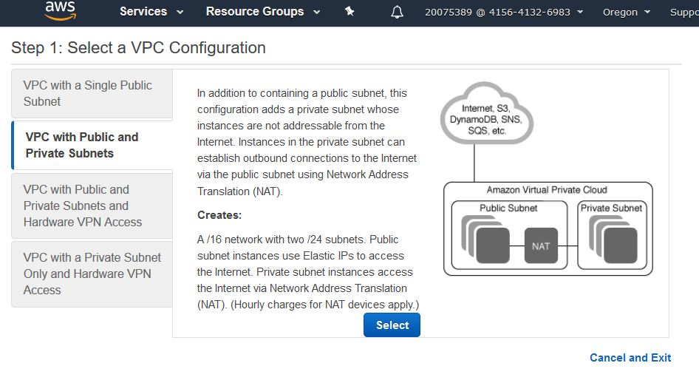

# Subnets

A subnet is a technique used to divide networks into subnetworks (subnets).

I named my VPC MichaelaVPC and gave it an IP address range of 192.168.0.0/16. I created two subnets, one public and one private. The public one is called MyPublicSubnet and has an IP address of 192.168.1.0/24 and the private one is called PrivateSubnet with an address of 192.168.2.0/24 and I attached them to my vpc. By default, all subnets are private so I had to make the public subnets not private.

# Internet Gateway and Route Table

A route table is a set of instructions which are used to direct network traffic. The internet gateway is an available VPC component which allows instances to communicate within the VPC and the internet.

To do this, I created an Internet Gateway called myInternetGateway and attached it to my vpc.

I then created my Route Table and added a route to the internet gateway I created and put the target as my internet gateway. I then went into the subnet associations tab and edited it so that my route table will be communicating the public subnet to the internet gateway. I did not add my private subnet because I did not want the public to access it through my gateway.

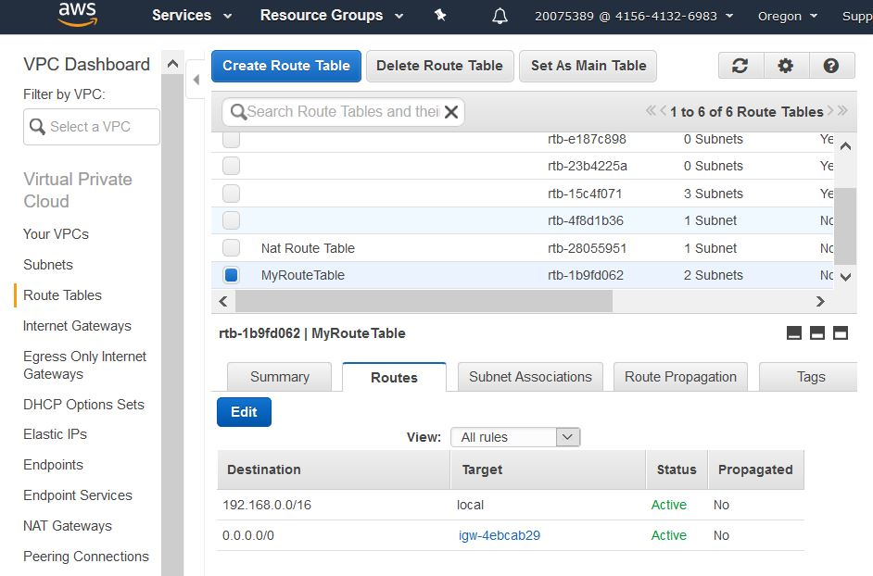

# Instance and Security Group

I then created an instance and put the network as my vpc and the subnet as the public subnet I created. I enabled the option to auto-assign a public ip address which allows the instance to be accessible by the public. I gave the instance a tag of WebServer and I created a security group to control traffic between the subnets. I called it Securitygroupforwebservers and added the rules http on port 80 and https on port 443 to allow access from my ip address.

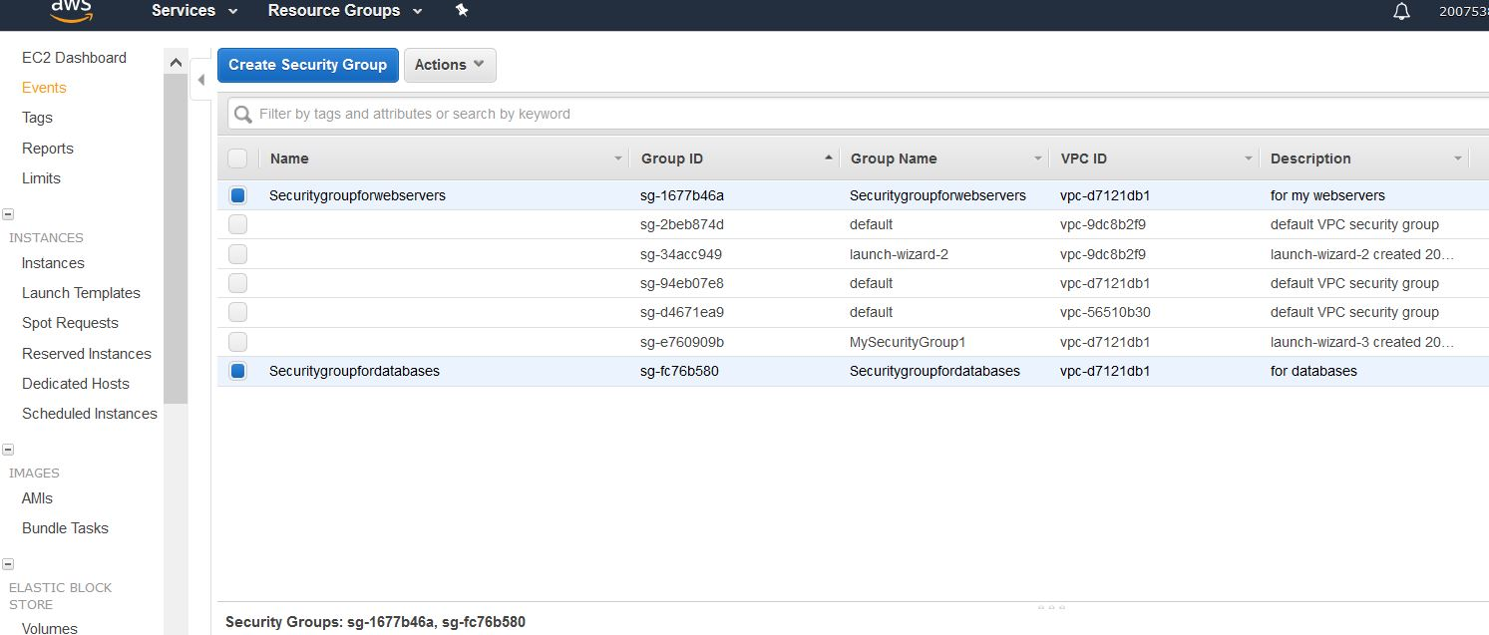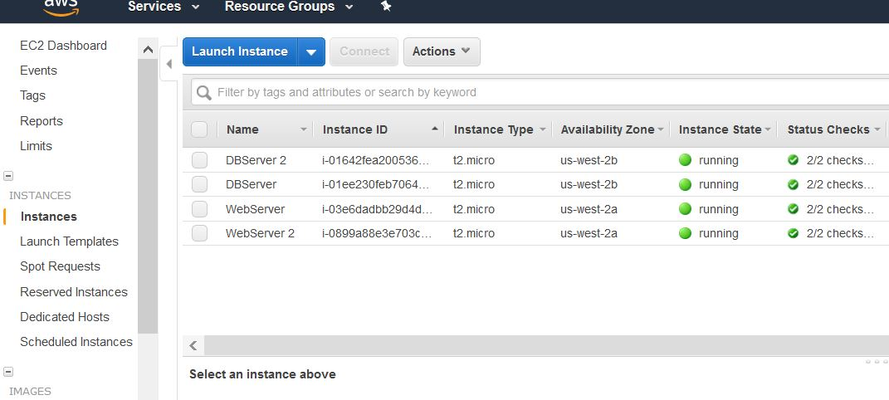

# KeyPair

The keypair I created is called MichaelasKeyPair10 and downloaded the.pem file. Then I went into my running instances and got the public ip address, copied it and pasted it into the host name of putty. Putty is a tool for remote access to another computer. I then went into ssh and clicked auth and browsed for my keypair.pem in the private key file for authentication tab. I had problems creating the keypairs because every time I downloaded my key pair it downloaded as a .ppk file and not a .pem file and I forgot to use puttygen to generate the public/private key pair.

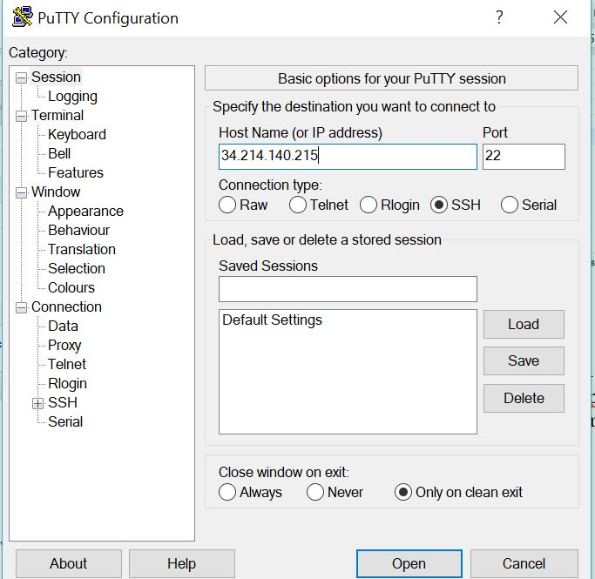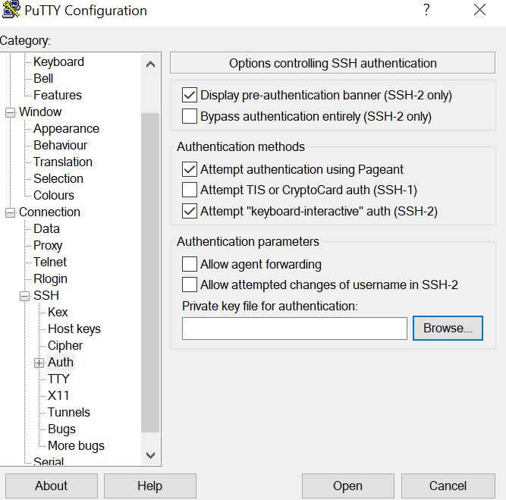

I then pressed open and a window appeared which shows it connecting, which means I have an instance that I’m accessing from outside the vpc.

# Load Balancing

For this assignment I assigned load balancing and I picked the classic load balancer as I wanted it to provide load balancing across multiple instances. Load balancing can distribute incoming traffic to instances in a single availability zone or multiple. I chose the load balancing for my two webserver instances. The classic load balancer automatically scales its request handling capacity to incoming application traffic, in this case traffic coming from port 80 which is the http protocol.

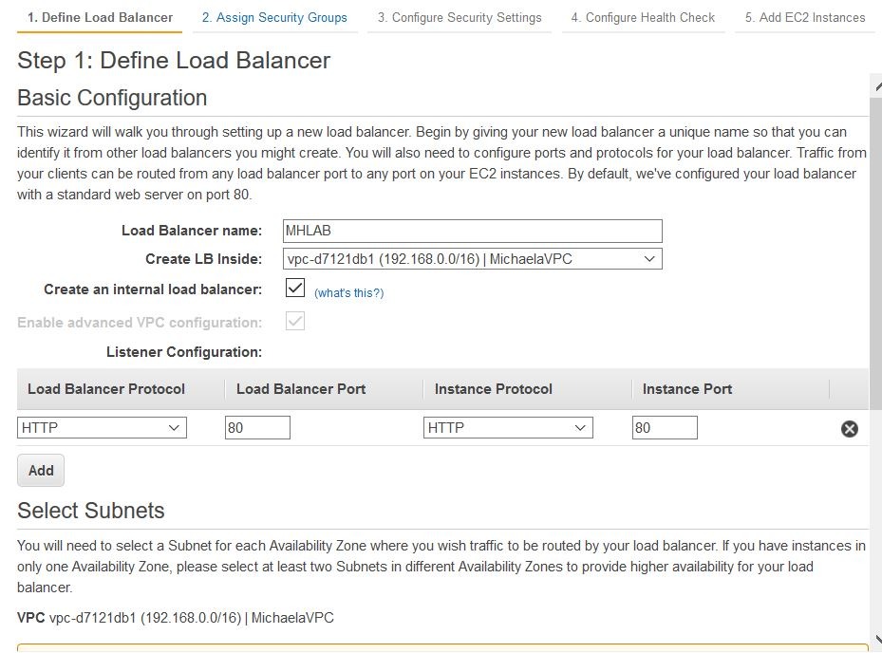

# Nat Gateway

I created a nat gateway for my vpc and for my private subnet and created a new elastic ip.

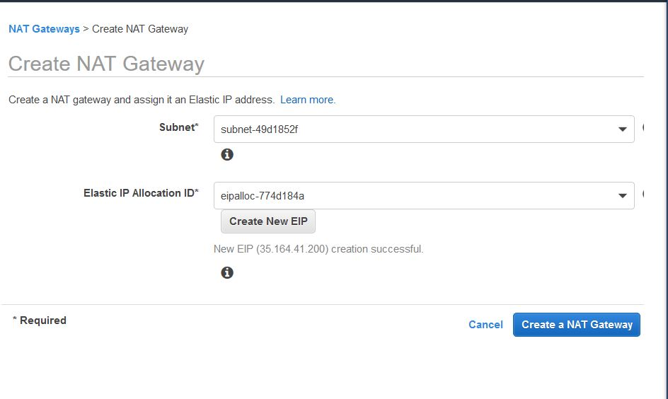

I then edited the route table and added the nat gateway as a route for the private subnet.

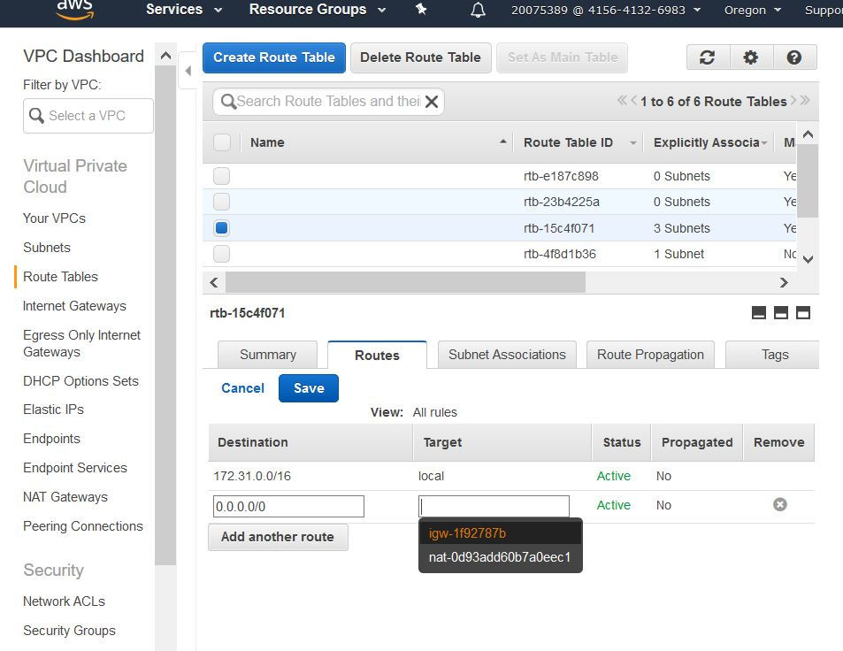

The nat gateway enables the instances in my private subnet to connect to the internet but prevents the internet from initiating a connection to these instances.

# Conclusion

In conclusion, I created a virtual private cloud with two subnets, one public and one private, an internet gateway and a route table to allow my public subnets connection to the internet gateway. I created instances and security groups and a key pair so I have access from outside the vpc. I assigned load balancing to manage traffic to the instances in the availability zones. Lastly, I created a nat gateway to enable the instances in my private subnet to connect to the internet. All of these processes when put together form a virtual private network which can be used to add privacy to both private and public networks such as WIFI hotspots and to protect data.